**CS 766 Computer Vision Final Project Proposal**

Saikat Raphael Gomes

University of Wisconsin, Madison

saikat@cs.wisc.edu

**Abstract**

*Over the years sports analytics has become more of a science that art. For the final project I propose to use Computer Vision and Machine Learning to create a powerful tool that will be used for sport analysis. With the help of computer vision I intent to analyze NFL plays and extract information and create a knowledge base on which we can run plethora of machine learning algorithms. The immediate goal is to create a prototype that can be eventually used in other sports as well.*

**1. Introduction**

Computer vision is widely used in sports television today, the line of scrimmage or the first down marker in NFL, the Hawk-Eye in cricket that is used to judge LBWs and motion tracking of a baseball are all such examples. Machine learning is also used extensively in the sports industry, in fact it is a multi-billion dollar industry (Vegas betting, fantasy sports etc.) Here I propose an application of both these fields to mine data from sport videos that can be eventually used for multiple purposes that range from simple analysis to complex machine learning predictions.

For this project I restrict the domain to American football because it involves a discrete number of plays per game. Advancements in computer vision in the last decade has made player tracking a fairly simple task. The intention of this project is to essentially digitize a large number of NFL plays. For a certain play the goal is to track all the players (offense: QB, WRs, RBs, TE, Linemen & defense: Linemen, CBs, Safeties etc.) and eventually classify each play and compile a database of plays. By tracking the trajectories of each player we can classify each play to a known (or unknown) permutation of plays available on the playbook.

Once such database is created the data can not only be used to give feedback to the players, coaches and scouts; but some heavy duty machine learning analysis can be employed to do predictions. For example before a match up the coaching staff usually spend a day watching tapes of the opponent team to understand their play calls, find weakness and strengths in their offense and defense that can exploited. We can instead feed the hours of video tapes into this tool that extracts each play and then we can run machine learning algorithms to learn patterns such as: what is the opponent coach’s go to play when he/she is down by a touchdown with 45 seconds left on the game clock.

Sport franchises spend a lot of resources each year on sports analytics to gain a competitive advantage. Therefore I feel there is demand for such a tool in the industry. Player tracking is done very commonly in most sports today, but to my knowledge no one mines data such as described above.

**2. Dataset**

Initially the goal was to use actual NFL game video as data for the project. But due to scarcity of available legal resources it was decided to train on Madden video game plays. Madden offers a realistic display that can used to train our model on. Each play can be replayed from multiple viewing angles. The eventual goal is to train on actual footage from both the NCAA and NFL level. A standard video capture tool will be used to record the plays. The goal is to have anywhere between 100 and 200 video captures of NFL plays. I intend to crowd-source the data collection aspect. A list of know play maps will be also created for matching and evaluation purpose.

**3. Methodology & Processing**

Once the dataset is created (figure 2), a tool will be created that processes individual plays to create spatio-temporal trajectories for each players. A collection of such trajectories for a given plays will be converted to an abstract play map (figure 3). This play map will be eventually codified and stored in a database. A classifier will be implemented that matches this map to a library of known plays.

Create standard (known) plays

[codified form]

Get play videos (Madden)

Track individual players for a given play and codify the play.

Compare and label these plays

Figure 1: Project pipeline.

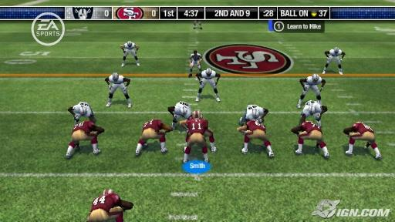

Figure 2: A screenshot from NFL Madden that will be used as dataset for this project.

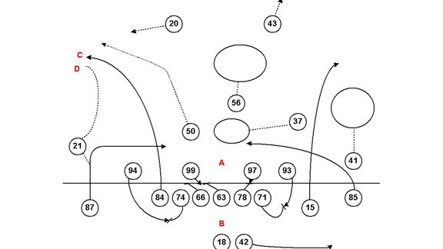

Figure 3: After tracking the trajectories of individual players a simplistic map like this will be created.

One of the challenges of the creating these trajectory maps will be location of the player/s with respect to the football field. The ten yard makers and the know dimensions of the football field will be used for this purpose. Another problem that can occur is occlusion. To circumvent this issue multiple view of the same play will be recorded.

From an initial survey it seems the top bird’s eye view might be the most helpful for this purpose. Other discrete information such as time of play execution, score and downs can be associated to create the database. Of course in this training phase the actual plays chosen by the user (denoted by arrows visually) will be ignored to mimic realistic footages.

**3.1 Play extraction**

Once we have successfully used motion tracking to create the temporal trajectories and computed the abstract play map the challenge is to codify this data so that statistical analysis can be performed later on down the stream. First step is to create a set of know plays. I intend to manually enter 15-20 such plays after consulting with domain experts. Each play will be stored as a collection of vectors (which can be stored on a relational database in the backend); One vector for every individual tractable route.

For computational purpose the vector representing a single temporal trajectory extracted (Rroutes) will be of the form:

Rroute = [ r1 , r2 , r3 , r4 ]

Where

r1 = player position [QB, WR, RB etc.]

r1 = route run [slant, comeback, corner etc.]

r1 = distance run

r1 = was player obstructed [Boolean]

A single play (Pi) will be a collection of such vector which will have a corresponding play label (Li)

Pi = [ R1 , R2 , … , Rx ]

**3.2 Play classifications**

The above codified data will be used for training and evaluating the classification model. A k-NN classifier and a SVM will be used to do the classification and evaluated based on accuracy.

**4. Tools Available**

To implement the above project I intend to use a variety of tools that are available to compliment the new code that will be written for the project. Matlab’s Computer Vision System Toolbox offers a variety of inbuilt functionality for automatic detection and motion-based tracking of moving objects in a video. I intend to implement most of the code for the project in Matlab. MySQL will be used as the backend database. In addition there are a few publications (see reference below) that will be used for implementing the player trajectory tracking.

**5. Evaluation**

The tool/method will be evaluated based on the number of accurate classifications of plays the algorithms makes. Especially since the dataset will be generated from user-controlled game in madden we know the play that has been chosen and executed. We can compared the classified play with this know information to evaluate the accuracy of the algorithm.

**6. Future Plans**

In the future the tool and algorithm will be run on actual footage (UW Madison football archives) and the goal is to run machine learning algorithms on the database create to learn coaching plays call.

**7. Conclusion**

In this project I propose the use of computer vision in sport analytics. There is huge demand for such a tool and I believe once we lay the groundwork for collecting and creating the classified data in a structured database many creative analytical method can be employed.

**References**

1. M. Perše, M. Kristan, J. Perš, S. Kovačič."Automatic Evaluation of Organized Basketball Activity". In: Michael Grabner, Helmut Grabner (eds.), Computer Vision Winter Workshop 2007, St. Lambrecht, Austria, pp.11-18. February 2007.
2. M. Kristan, J. Perš, M Perše, S. Kovačič."Towards fast and efficient methods for tracking players in sports". In: Proceedings of the ECCV Workshop on Computer Vision Based Analysis in Sport Environments, pp.14-25. May 2006.
3. M. Perse, M. Kristan, J. Pers, S. Kovacic."A Template-Based Multi-Player Action Recognition of the Basketball Game". In: Janez Pers, Derek R. Magee (eds.), Proceedings of the ECCV Workshop on Computer Vision Based Analysis in Sport Environments, Graz, Austria, pp.71-82. May 2006.
4. M. Perše, M. Kristan, J. Perš, G. Vučkovič, S. Kovačič. "Temporal segmentation of group motion using Gaussian Mixture Models". In: Janez Perš (ed.), Proceedings of Computer Vision Winter Workshop 2008 (CVWW08), Moravske Toplice, Slovenia pp.47-54. 4-6 February 2008.
5. Tracking Players in Sports Games - Team sports (Handball, Basketball) [Project webpage: http://vision.fe.uni-lj.si/RESEARCH/trackp/team.html]
6. B. G. Weber, M. John, M. Mateas and A. Jhala, "Modeling Player Retention in Madden NFL 11," in Proceedings of the Twenty-Third Conference on Innovative Applications of Artificial Intelligence (IAAI), 2011.
7. T. Zhang, B. Ghanem, and N. Ahuja. Robust multi-object tracking via cross-domain contextual information for sports video analysis. In ICASSP, 2012.
8. Jingchen Liu and Peter Carr and Robert T. Collins and Yanxi Liu. “Tracking Sports Players with Context-Conditioned Motion Models”. Computer Vision and Pattern Recognition (CVPR) 2013